5.1 Transmission Components
The transmitter to receiver communication session is composed of three basic elements: the Handshake Tone sequence, Message Blocks, and Acknowledgements. The Handshake Tone sequence consists of a pair of single-frequency tones sequenced in time. The Message Blocks consist of a series of DTMF tone bursts separated by spaces. The Acknowledgement Tone is a single tone burst.
5.1.1 Handshake Tones
The Handshake Tone sequence is produced by the RECEIVER. The purpose is to signal the TRANSMITTER that the communication channel is ready.
5.1.1.1 Placement
5.1.1.2 Composition
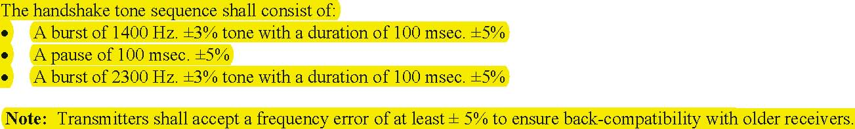
A 1400 Hz / 800 ms or 1000 ms is also considered valid.
5.1.2 Message Blocks
A Message Block is sent by the TRANSMITTER for each message in the transmitter’s message queue. Each message block contains sufficient information to report an event in the system.
5.1.2.1 Placement
The first message block is sent beginning 250 msec. (250 min.,300 max.) after the end of either the Handshake Tone sequence or after a Kissoff (Acknowledgement) tone. The delay is timed from the end of the tone.
5.1.2.2 Message Composition
The form of the message is:
ACCT MT QXYZ GG CCC
where: ACCT = 4 Digit Account number (0-9, B-F)

MT = Message Type. This 2-digit sequence is used to identify the Contact ID message to the receiver. It may be transmitted as either 18 (preferred) or 98 (optional). New receiver implementations shall accept either a 18 or a 98. Note that some older recei

v

ers may not accept 98 .

Note 1:
With message type 58, the alarm string is as follows:
AAAA MT AAAAAA Q XYZ GG CCC P
68: Contact ID with ADT Capture.
Q = Event qualifier, which gives specific event information: 1 = New Event or Opening 3 = New Restore or Closing
6 = Previously reported condition still present (Status report)
XYZ = Event code (3 Hex digits 0-9,B-F)
GG = Group or Partition number (2 Hex digits 0-9, B-F). Use 00 to indicate that no specific group or partition information
applies. CCC = Zone number (Event reports) or User # (Open / Close reports ) (3 Hex digits 0-9,B-F ). Use 000 to indicate that no
specific zone or user information applies
S = 1 Digit Hex checksum calculated such that:
(Sum of all message digits + S) MOD 15 = 0
Note: A ‘0’ shall be transmitted as a 10 and valued as a 10 for checksum purposes even though it is displayed and printed as
‘0’. It uses the same tone pair as the ‘0’ (OPER) key on a standard telephone.
5.1.2.3 Data Tones
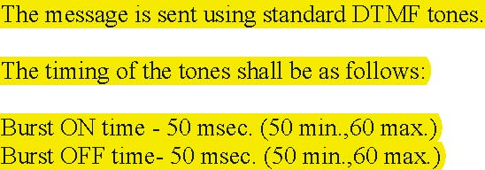
The details of the tones are contained in the following table.
Data Transmission Frequencies
Standard DTMF Signaling

Digit | Low Tone (Hz.) |  | High Tone (Hz. ) |  | Digit Value
0 | 941 |  | 1336 |  | 10
1 |  | 697 |  | 1209 |  |  | 1
2 |  | 697 |  | 1336 |  |  | 2
3 |  | 697 |  | 1477 |  |  | 3
4 |  | 770 |  | 1209 |  |  | 4

5 | 770 |  | 1336 |  | 5
6 | 770 |  | 1477 |  | 6
7 |  | 852 |  | 1209 |  |  | 7
8 |  | 852 |  | 1336 |  |  | 8
9 |  | 852 |  | 1477 |  |  | 9
B (*) |  | 941 |  | 1209 |  |  | 11
C (#) |  | 941 |  | 1477 |  |  | 12
D |  | 697 |  | 1633 |  |  | 13
E |  | 770 |  | 1633 |  |  | 14
F |  | 852 |  | 1633 |  |  | 15

Notes:
1) The digit ‘0’ is transmitted with a value of 10 and shall be counted as a 10 in the calculation of the message checksum.
2) The DTMF pair of 941 Hz. And 1633 Hz. is not used in this format and shall not be sent.
3) The frequency deviation on each of the above frequencies shall be ± 1.5% max.
5.1.3 Inter-Message Time
After sending its message, the transmitter should wait for 1.25 sec. for the start of a Kissoff Tone from the receiver. If the start of a kissoff tone is detected, the transmitter must continue timing the tone, even if the inter-message time expires. The panel must detect a minimum of 400 msec. of the Kissoff Tone for it to be considered to be valid.
If a Kissoff tone is detected, the transmitter should wait for the tone to end and then wait 250 msec. (250 min.,300 max.) before beginning the next message. If no Kissoff Tone is received, the transmitter should repeat the message after the expiration of the 1.25 second inter-message interval.
5.1.4 Kissoff (Acknowledgement) Tone
Note: Transmitters shall accept a frequency error of at least ± 5% to ensure back-compatibility with older receivers
5.1.5 Maximum Number Of Attempts

5.2 Data Codes
The data codes used to transmit events are contained in Appendix C: Event Codes.
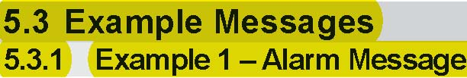

Account 1234 is reporting a Perimeter Burglary Alarm on Zone 15 of Partition 1
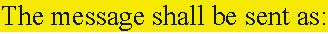
1234 18 1131 01 015 8
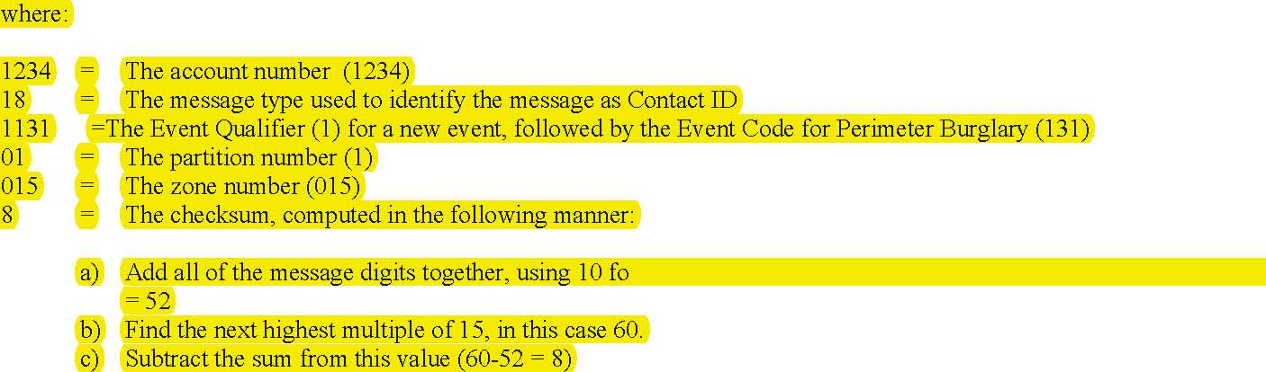
5.3.2 Example 2 – Restoral Message
Account 1234 is reporting a Restore of a Perimeter Burglary Alarm on Zone 15 of Partition 1 The message shall be sent as:
1234 18 3131 01 015 6
where:
1234 = The account number (1234) 18 = The message type used to identify the message as Contact ID 3131 = The Event Qualifier (3) for a restoral, followed by the Event Code for Perimeter Burglary (131) 01 = The partition number (1) 015 = The zone number (015) 6 = The checksum (See Example 1)
5.3.3 Example 3 – Opening Message
User 3 disarms Partition 2 of Account 1234 The message shall be sent as:
1234 18 1401 02 003 5
where
1234 = The account number (1234) 18 = The message type used to identify the message as Contact ID 1401 = The Event Qualifier (1) for an Opening, followed by the Event Code for Open/Close by User (401)

02 = The partition number (2) 003 = The User number (003) 5 = The checksum (See Example

1)

5.3.4 Example 4 – Closing Message
User 5 arms Partition 3 of Account 1234
The message shall be sent as:
1234 18 3401 03 005 F
where
1234 = The account number (1234) 18 = The message type used to identify the message as Contact ID 3401 = The Event Qualifier (3) for a Closing, followed by the Event Code for Open/Close by User (401) 03 = The partition number (2) 005 = The User number (003) F = The checksum (See Example 1)
Note the use of ‘F’ since the sum of the message digits is an even multiple of 15.

5.4 Message Transmission Flowchart
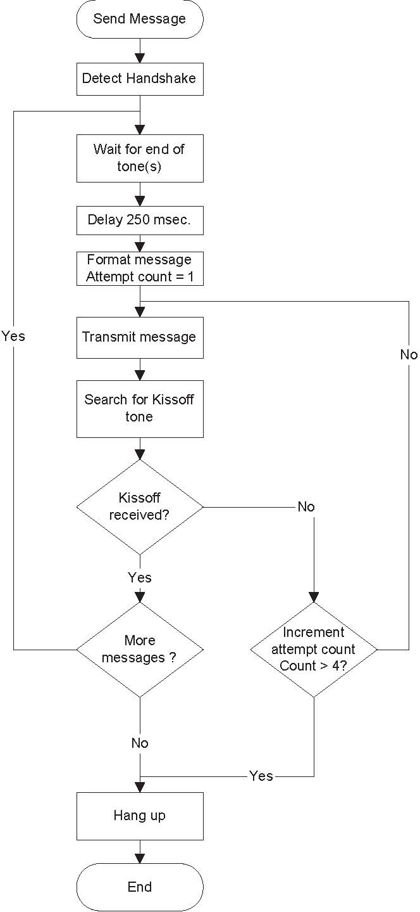

5.5 Event Codes
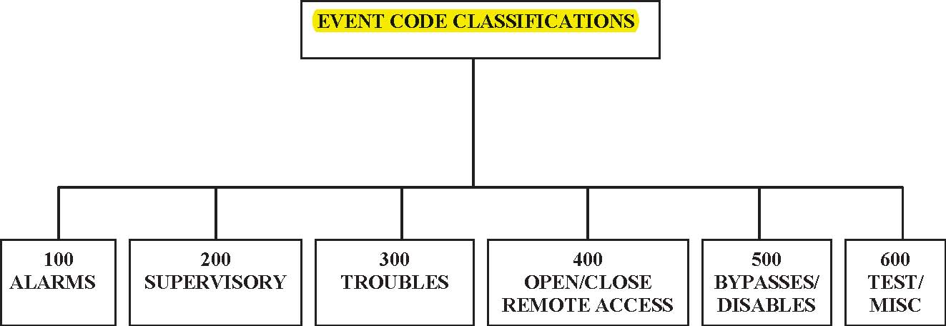

Medical | Fire |  | System |  |  | Open/Close |  | System |  | Test
Fire |  |  | Sounder/Relay |  |  | Remote Access |  | Sounder/Rly |  | Log
Panic |  |  |  | Sys. Per. | Access Control |  | Sys. Per. |  | Sched.
Burglary |  |  |  | Comm. |  |  | Comm.
General |  |  | Prot. Loop
24 Hour |  |  | Sensor

The following table defines the Event Codes used in this protocol. The Data Type identifies the information sent in the CCC field as either Zone number or User number. The value in the CCC field should be set to 000 if no useful information is being sent. Descriptions for the Event Codes will be added in a later revision of this standard.

Event | Data Type | Descriptions (to be supplied in a later revision of this standard)
ALARMS
Medical Alarms –100
100 Medical | Zone | A non-specific medical condition exists
101 Personal Emergency | Zone | Emergency Assistance request
102 Fail to report in | Zone | A user has failed to activate a monitoring device
Fire Alarms –110
110 Fire | Zone | A non-specific fire alarm condition exists
111 Smoke | Zone | An alarm has been triggered by a smoke detector
112 Combustion | Zone | An alarm has been triggered by a combustion detector
113 Water flow | Zone | An alarm has been triggered by a water flow detector
114 Heat | Zone | An alarm has been triggered by a heat detector
115 Pull Station | Zone | A pull station has been activated
116 Duct | Zone | An alarm has been triggered by a duct detector
117 Flame | Zone | An alarm has been triggered by a flame detector
118 Near Alarm | Zone | A near-alarm condition has been detected on a fire sensor
Panic Alarms –120
120 Panic | Zone | A non-specific hold-up alarm exists
121 Duress | User | A duress code has been entered by a user
122 Silent | Zone | A silent hold-up alarm exists
123 Audible | Zone | An audible hold-up alarm exists
124 Duress – Access granted | Zone | A duress code has been granted at an exit door
125 Duress – Egress granted | Zone | A duress code has been entered at an entry door
126 Hold-up suspicion print | User | A user has activated a trigger to indicate a suspicious condition
Burglar Alarms –130
130 Burglary | Zone | A burglary zone has been violated while armed
131 Perimeter | Zone | A perimeter zone has been violated while armed
132 Interior | Zone | An interior zone has been violated while armed
133 24 Hour (Safe) | Zone | A 24 hour burglary zone has been violated
134 Entry/Exit | Zone | An Entry/Exit zone has been violated while armed
135 Day/night | Zone | A Day/Night zone has been violated while armed
136 Outdoor | Zone | An outdoor burglary zone has been violated while armed
137 Tamper | Zone | A burglary zone has been tampered with while armed
138 Near alarm | Zone
139 Intrusion Verifier | Zone
General Alarm – 140
 | Zone
140 General Alarm | Zone
141 Polling loop open | Zone

Event | Data Type | Descriptions (to be supplied in a later revision of this standard)
142 Polling loop short | Zone
143 Expansion module failure | Zone
144 Sensor tamper | Zone
145 Expansion module tamper | Zone
146 Silent Burglary | Zone
147 Sensor Supervision Failure | Zone | A sensor has not reported in during an armed state
24 Hour Non-Burglary - 150 and 160
150 24 Hour Non-Burglary | Zone
151 Gas detected | Zone
152 Refrigeration | Zone
153 Loss of heat | Zone
154 Water Leakage | Zone
155 Foil Break | Zone
156 Day Trouble | Zone
157 Low bottled gas level | Zone
158 High temp | Zone
159 Low temp | Zone
161 Loss of air flow | Zone
162 Carbon Monoxide detected | Zone
163 Tank level | Zone
SUPERVISORY
Fire Supervisory -200 and 210
200 Fire Supervisory | Zone
201 Low water pressure | Zone
202 Low CO2 | Zone
203 Gate valve sensor | Zone
204 Low water level | Zone
205 Pump activated | Zone
206 Pump failure | Zone
TROUBLES
System Troubles -300 and 310
300 System Trouble | Zone
301 AC Loss | Zone
302 Low system battery | Zone
303 RAM Checksum bad | Zone
304 ROM checksum bad | Zone
305 System reset | Zone
306 Panel programming changed | Zone
307 Self-test failure | Zone
308 System shutdown | Zone
309 Battery test failure | Zone
310 Ground fault | Zone
311 Battery Missing/Dead | Zone
312 Power Supply Overcurrent | Zone
313 Engineer Reset | User
314 Primary Power Supply Failure | Zone | The primary power supply has failed

Event | Data Type | Descriptions (to be supplied in a later revision of this standard)
Sounder / Relay Troubles -320
320 Sounder/Relay | Zone
321 Bell 1 | Zone
322 Bell 2 | Zone
323 Alarm relay | Zone
324 Trouble relay | Zone
325 Reversing relay | Zone
326 Notification Appliance Ckt. # 3 | Zone
327 Notification Appliance Ckt. #4 | Zone
System Peripheral Trouble -330 and 340
330 System Peripheral trouble | Zone
331 Polling loop open | Zone
332 Polling loop short | Zone
333 Expansion module failure | Zone
334 Repeater failure | Zone
335 Local printer out of paper | Zone
336 Local printer failure | Zone
337 Exp. Module DC Loss | Zone
338 Exp. Module Low Batt. | Zone
339 Exp. Module Reset | Zone
341 Exp. Module Tamper | Zone
342 Exp. Module AC Loss | Zone
343 Exp. Module self-test fail | Zone
344 RF Receiver Jam Detect | Zone | An RF receiver has detected continuous carrier
Communication Troubles -350 and 360
350 Communication trouble | Zone
351 Telco 1 fault | Zone
352 Telco 2 fault | Zone
353 Long Range Radio xmitter fault | Zone
354 Failure to communicate event | Zone
355 Loss of Radio supervision | Zone
356 Loss of central polling | Zone
357 Long Range Radio VSWR problem | Zone
Protection Loop -370
370 Protection loop | Zone
371 Protection loop open | Zone
372 Protection loop short | Zone
373 Fire trouble | Zone
374 Exit error alarm (zone) | Zone
375 Panic zone trouble | Zone
376 Hold-up zone trouble | Zone
377 Swinger Trouble | Zone | A zone that has previously exceeded the max. alarm report count for swingers has faulted again (SIA False Alarm)
378 Cross-zone Trouble | Zone | Only one of the sensors in a cross-zoned pair has triggered within a 5 minute window (SIA False Alarm)

Event | Data Type | Descriptions (to be supplied in a later revision of this standard)
Sensor Trouble -380
380 Sensor trouble | Zone
381 Loss of supervision -RF | Zone
382 Loss of supervision -RPM | Zone
383 Sensor tamper | Zone
384 RF low battery | Zone
385 Smoke detector Hi sensitivity | Zone
386 Smoke detector Low sensitivity | Zone
387 Intrusion detector Hi sensitivity | Zone
388 Intrusion detector Low sensitivity | Zone
389 Sensor self-test failure | Zone
391 Sensor Watch trouble | Zone
392 Drift Compensation Error | Zone
393 Maintenance Alert | Zone
OPEN/CLOSE/REMOTE ACCESS
Open/Close -400, 440,450,460
400 Open/Close | User
401 O/C by user | User
402 Group O/C | User
403 Automatic O/C | User
404 Late to O/C (Note: use 453, 454 instead ) | User
405 Deferred O/C (Obsolete- do not use ) | User
406 Cancel | User
407 Remote arm/disarm | User
408 Quick arm | User
409 Keyswitch O/C | User
441 Armed STAY | User
442 Keyswitch Armed STAY | User
450 Exception O/C | User
451 Early O/C | User
452 Late O/C | User
453 Failed to Open | User
454 Failed to Close | User
455 Auto-arm Failed | User
456 Partial Arm | User
457 Exit Error (user) | User
458 User on Premises | User
459 Recent Close | User
461 Wrong Code Entry | Zone
462 Legal Code Entry | User
463 Re-arm after Alarm | User
464 Auto-arm Time Extended | User
465 Panic Alarm Reset | Zone
466 Service On/Off Premises | User | An alarm service person has entered / left the premises

Event | Data Type | Descriptions (to be supplied in a later revision of this standard)
Remote Access –410
411 Callback request made | User
412 Successful download/access | User
413 Unsuccessful access | User
414 System shutdown command received | User
415 Dialer shutdown command received | User
416 Successful Upload | Zone
Access control –420,430
421 Access denied | User
422 Access report by user | User
423 Forced Access | Zone
424 Egress Denied | User
425 Egress Granted | User
426 Access Door propped open | Zone
427 Access point Door Status Monitor trouble | Zone
428 Access point Request To Exit trouble | Zone
429 Access program mode entry | User
430 Access program mode exit | User
431 Access threat level change | User
432 Access relay/trigger fail | Zone
433 Access RTE shunt | Zone
434 Access DSM shunt | Zone
435 Second Person Access | User | The second person required for a 2 person operation has entered a code
436 Irregular Access | User | An access out of the normal time window has occurred
BYPASSES / DISABLES
System Disables -500 and 510
501 Access reader disable | Zone
Sounder / Relay Disables –520
520 Sounder/Relay Disable | Zone
521 Bell 1 disable | Zone
522 Bell 2 disable | Zone
523 Alarm relay disable | Zone
524 Trouble relay disable | Zone
525 Reversing relay disable | Zone
526 Notification Appliance Ckt. # 3 disable | Zone
527 Notification Appliance Ckt. # 4 disable | Zone
System Peripheral Disables -530 and 540

Event | Data Type | Descriptions (to be supplied in a later revision of this standard)
531 Module Added | Zone
532 Module Removed | Zone
Communication Disables -550 and 560
551 Dialer disabled | Zone
552 Radio transmitter disabled | Zone
553 Remote Upload/Download disabled | Zone
Bypasses –570
570 Zone/Sensor bypass | Zone
571 Fire bypass | Zone
572 24 Hour zone bypass | Zone
573 Burg. Bypass | Zone
574 Group bypass | User
575 Swinger bypass | Zone
576 Access zone shunt | Zone
577 Access point bypass | Zone
578 Vault Bypass | Zone | A vault protection zone has been bypassed
579 Vent Zone Bypass | Zone | A vent zone (window) has been bypassed so it can be left open
TEST / MISC.
Test/Misc. –600, 610
601 Manual trigger test report | Zone
602 Periodic test report | Zone
603 Periodic RF transmission | Zone
604 Fire test | User
605 Status report to follow | Zone
606 Listen-in to follow | Zone
607 Walk test mode | User
608 Periodic test - System Trouble Present | Zone
609 Video Xmitter active | Zone
611 Point tested OK | Zone
612 Point not tested | Zone
613 Intrusion Zone Walk Tested | Zone
614 Fire Zone Walk Tested | Zone
615 Panic Zone Walk Tested | Zone
616 Service Request | Zone
Event Log –620
621 Event Log reset | Zone
622 Event Log 50% full | Zone
623 Event Log 90% full | Zone
624 Event Log overflow | Zone
625 Time/Date reset | User
626 Time/Date inaccurate | Zone

Event | Data Type | Descriptions (to be supplied in a later revision of this standard)
627 Program mode entry | Zone
628 Program mode exit | Zone
629 32 Hour Event log marker | Zone
Scheduling –630
630 Schedule change | Zone
631 Exception schedule change | Zone
632 Access schedule change | Zone
Personnel Monitoring -640
641 Senior Watch Trouble | Zone
642 Latch-key Supervision | User
Misc. –650, 700
651 Reserved for Ademco Use | Zone
652 Reserved for Ademco Use | User
653 Reserved for Ademco Use | User
654 System Inactivity | Zone | The system has not been armed for a preset number of days
703 Auxiliary #3 | Zone | Old Westgarde code –unknown meaning
704 Installer Test | Zone | Old Westgarde code – unknown meaning
750-789 “User Assigned” |  | * See note below
796 Unable to output signal (Derived Channel) | Zone
798 STU Controller down (Derived Channel) | Zone
900 Download Abort | Zone | A downloading process was aborted manually
901 Download Start/End | Zone | A download session started/ended
902 Download Interrupted | Zone | A downloading session was interrupted
910 Auto-close with Bypass | Zone | A system auto-armed itself and bypassed one or more zones in the process
911 Bypass Closing | Zone | A system was armed with one or more zones bypassed
912 Fire Alarm Silence | Zone | A fire alarm has been silenced
913 Supervisory Point test Start/End | User | A serviceman test of supervisory-type zones has started /ended
914 Hold-up test Start/End | User | A serviceman test of hold-up-type zones has started /ended
915 Burg. Test Print Start/End | User | (Local only – no dialer)
916 Supervisory Test Print Start/End | User | (Local only – no dialer)
917 Burg. Diagnostics Start/End | Zone
918 Fire Diagnostics Start/End | Zone
919 Untyped diagnostics | Zone
920 Trouble Closing (closed with burg. during exit) | User | The system was armed but a burg alarm occurred during the exit delay period
921 Access Denied Code Unknown | User | Logs refusal to grant access

Note – “User Defined” Event codes
Event codes in the 750-789 range hve been reserved for “User Assigned” reports. These event codes may be used for nonstandard events that do not fit within industry definitions. Since the definition of these codes may vary from company to company, and even from account to account, it is the Central Station’s responsibility to manage their code assignments.

Event | Data Type | Descriptions (to be supplied in a later revision of this standard)
922 Supervisory Point Alarm | Zone
923 Supervisory Point Bypass | Zone
924 Supervisory Point Trouble | Zone
925 Hold-up Point Bypass | Zone
926 AC Failure for 4 hours | Zone
927 Output Trouble | Zone
928 User code for event | User | Provides user info to indicate which user bypassed a point
929 Log-off | User

